Ubuntu Linux Server using Virtual Box

Virtual Box: [virtual box link](http://www.oracle.com/technetwork/server-storage/virtualbox/downloads/index.html)

Ii **Download Ubuntu Images**:

On the student distrib drive (**M:\OS 2 Ubuntu virtual images\virtual box**) : you will find an images for the virtual box ubuntu image : **ubuntu-14.04-server-i386.7z**

III.

**Running linux on the PC in the Computer Labs**

* Copy the selected archive file to a folder on the D: drive
* extract the entire archive by right-­‐clicking on the downloaded file and choosing "*Extract Here*"

**Running linux on your PC/Laptop (The instructions have been tested for windows 7)**

Copy the ubuntu image file from the student drive to a folder on your PC/Laptop.

extract the entire archive by right-­‐clicking on the downloaded file and choosing "*Extract Here*"

.

IV. Virtual box installation

Open virtual box and go to menu option:  **Machine -> add.** *(your installation will not have the images shown in the left hand window in the diagram below )*

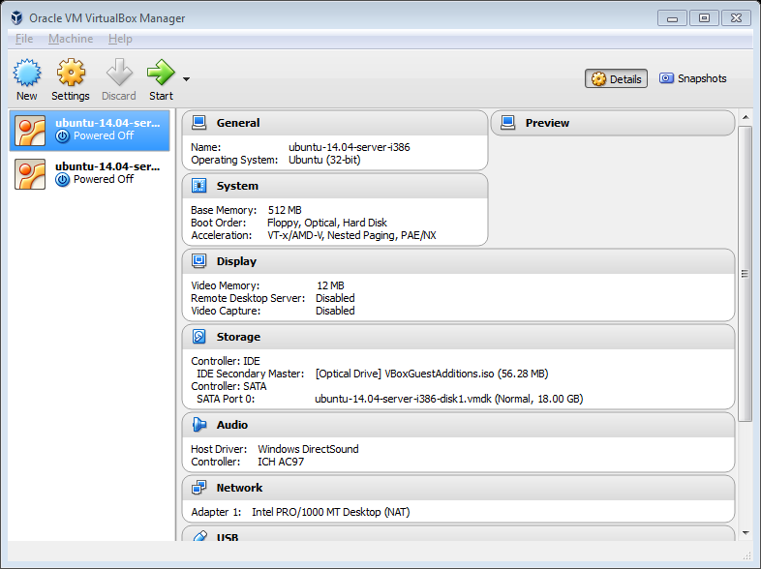

browse to the folder on the PC/Laptop and click on the *vbox file* as shown below

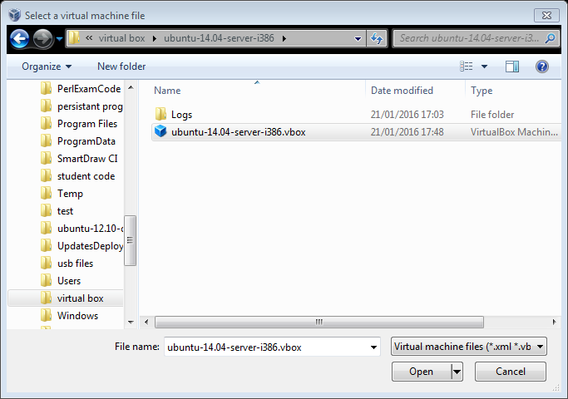

It will give you the following

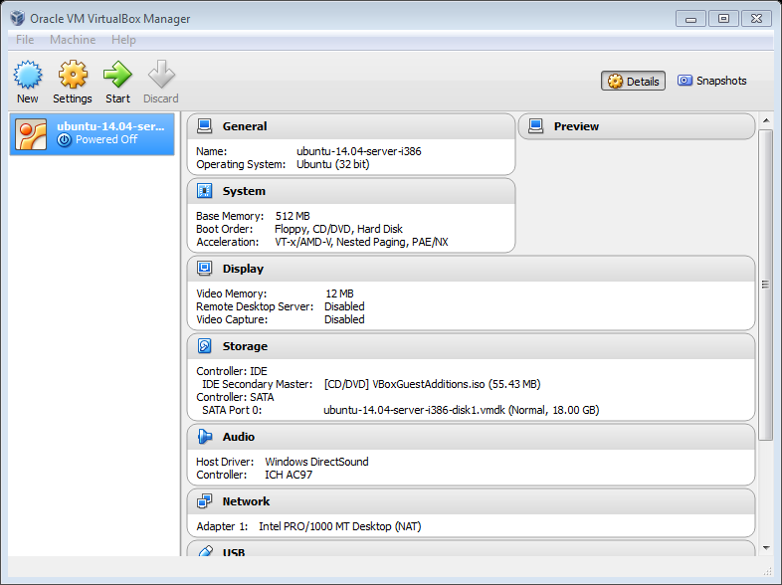

**Click on Start** and when prompted input:

User name is **ubuntu**

Password**: reverse (note you will not see the password appear on the command line window)**

. it should then give you the following command line virtual box window:

